Háskólinn í Reykjavík 1.mars 2015

Sálfræðisvið

Test and measurement in Psychology

8,4 or 21/25

**Computer assignment 2**

Daria Rudkova

Sunneva Reynisdóttir Cristopher David Desjardins

**Question 1**

a) The easiest item was item number 5 with -1,62 and the hardest was item 10 with 0,52.

Item 5 -1.62671110

Item 10 0.52959427

b) We provide a 95% confidence interval for the easiest item which is number 5. We calculate that in R, we took difficulty for item 5 and did plus/minus with 1.96 and then we multiplied with the SE for item number 5.

-1.62671110+1.96*0.1320051= -1.367981

-1.62671110-1.96*0.1320051= -1.885441

Interpretation? -1

c) The black line is item number 5 and the red line is item number 10. The lines are inversed of each other. Which make sense because this two items are easiest and the hardest items on the test.

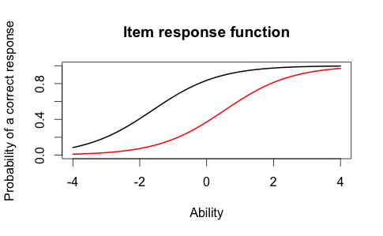

d) For item 10 the correct response would be around 0,35 for someone who has ability score of 0. For item 5 the correct response would be around 0,8 for someone who has ability score of 0. Which make sense because item 5 is easier than item 10 and that's why it has higher probability of a correct response.

e) The person who scored best on the test had 3,99 scores and was number 49. The person who scored worst on the test had -3,99 and was number 393.

min(est_abl$est)

-3.999947

max(est_abl$est)

3.999921

which.min(est_abl$est)

393

which.max(est_abl$est)

49

f) We provide a 95% confidence interval for estimated ability for the students with the best score on the test. We took the highest score and did plus/minus with 1.96 and then we multiplied with the SEM for the highest score.

3.999921+1.96*2.204373 = 8.320492

3.999921-1.96*2.204373 = -0.3206501

Interpretation -1

**Question 2**

a) We choose item 5, 10 and 15.

b)

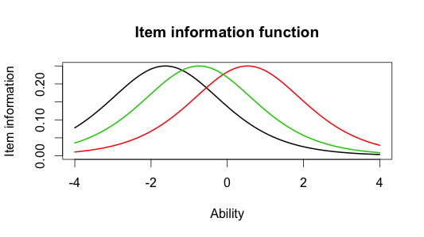

c) The black line (item 5) is the easiest because it has the highest point in ability -2. The hardest item was the red line (item 10) because the highest point of that line is around 1 in ability. In the middle is the green line (item 15) with ability around -1. The lines have in common that they have most information around the middle. They have the same shape -1

d)

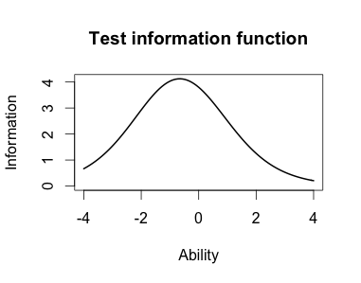

e) The majority of the information is around -2 to 1.

**Question 3**

a) Item 17 has the highest discrimination or 1.86 and item 12 has the lowest discrimination or 0,33. Should be item 8 not 17. -1

Item 17 1.8591845

Item 12 0.3329130

b) In 2-PL model the hardest item was 10 as well as in Rasch model. On the other hand the easiest item in 2-PL model was the item number 1. In the Rasch model was the easiest item number 5.

Item 1 -2.00058101

Item 10 0.48542889

c) The correlation between the ability estimate on the Rasch model and the 2-PL model was 0,97. We would draw the same conclusion from both models because the correlation between ability estimates on both model is high.

cor(twopl_abl$est,est_abl$est)

0.9709497

d)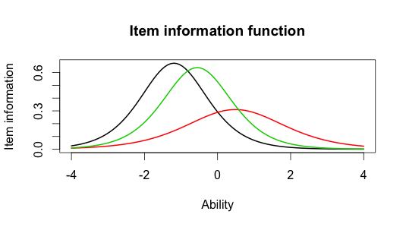

e) In the 2-PL model the hardest item number 10 look diferent than item 5 and 15. In Rasch model the three lines look similar. Depend on 2-PL model we have less information from item 10. Also the information gap in 2-Pl model for item 5 and 15 is smaller than in Rasch model. We think that it means that 2-PL model is more detalied. It is more flexible.